Session-47 Introduction to Database

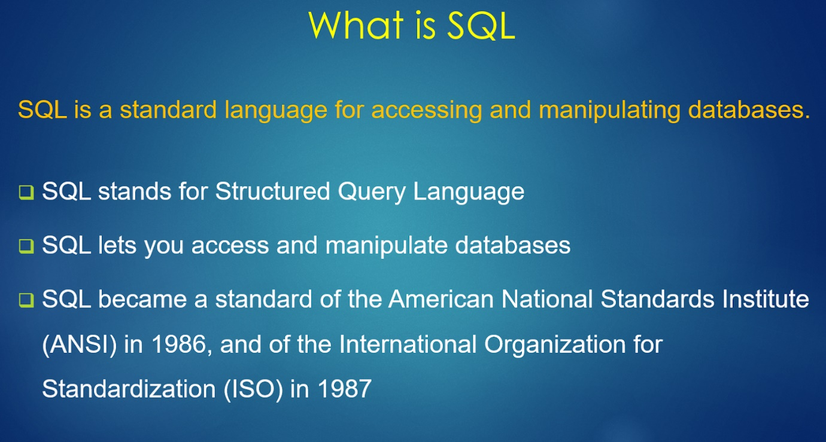

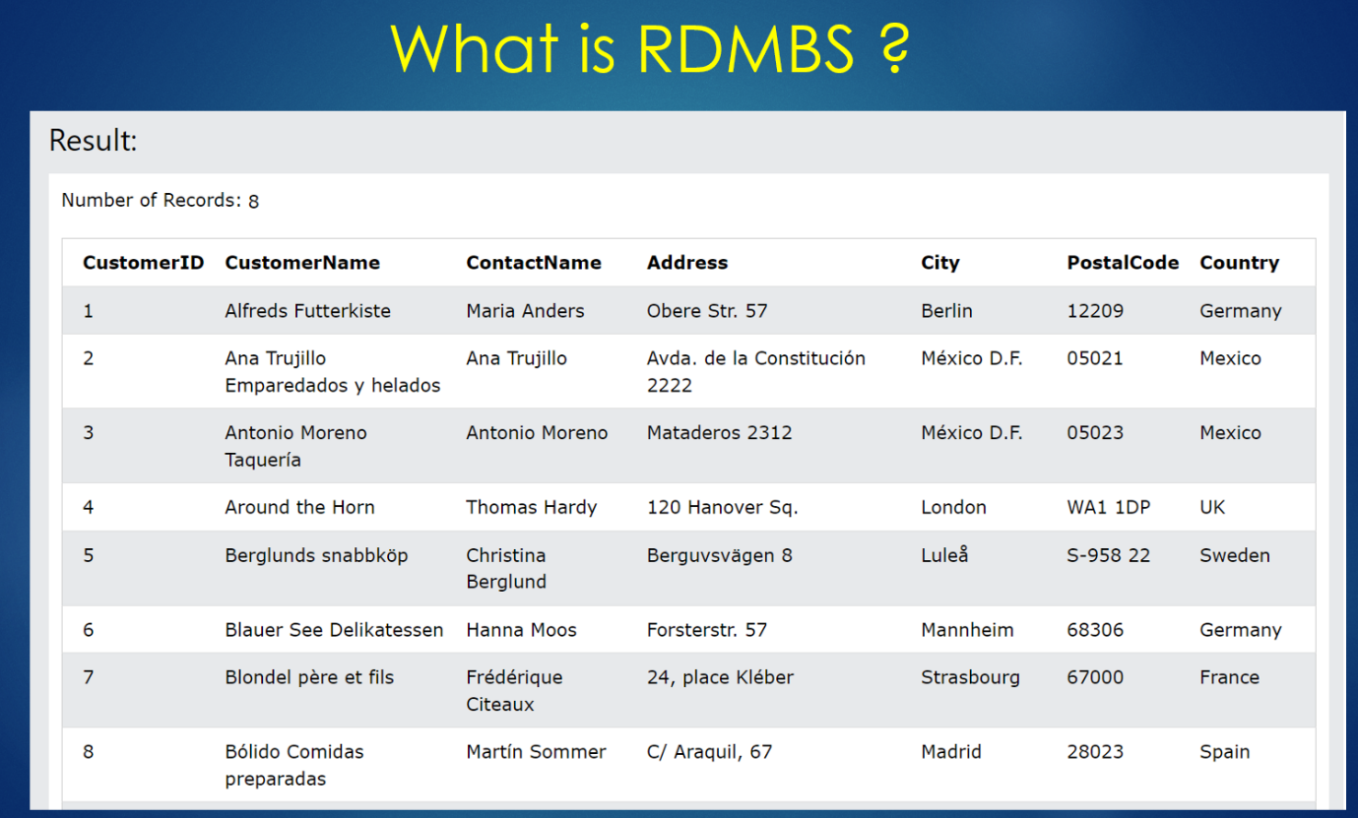

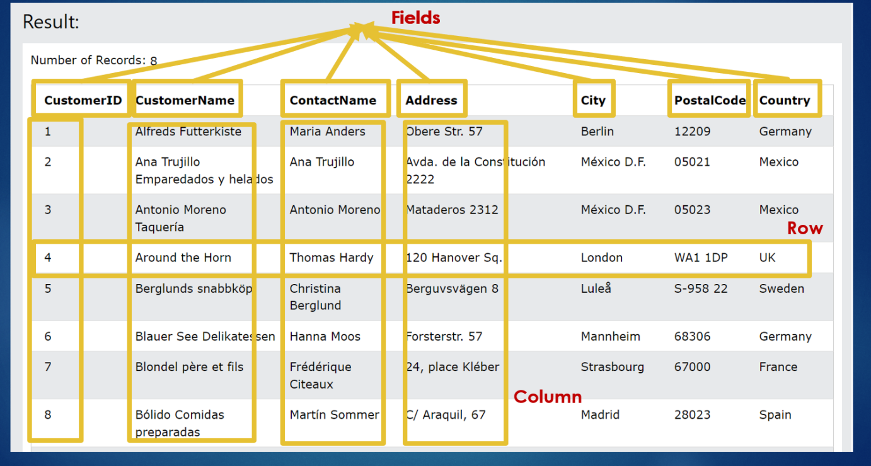

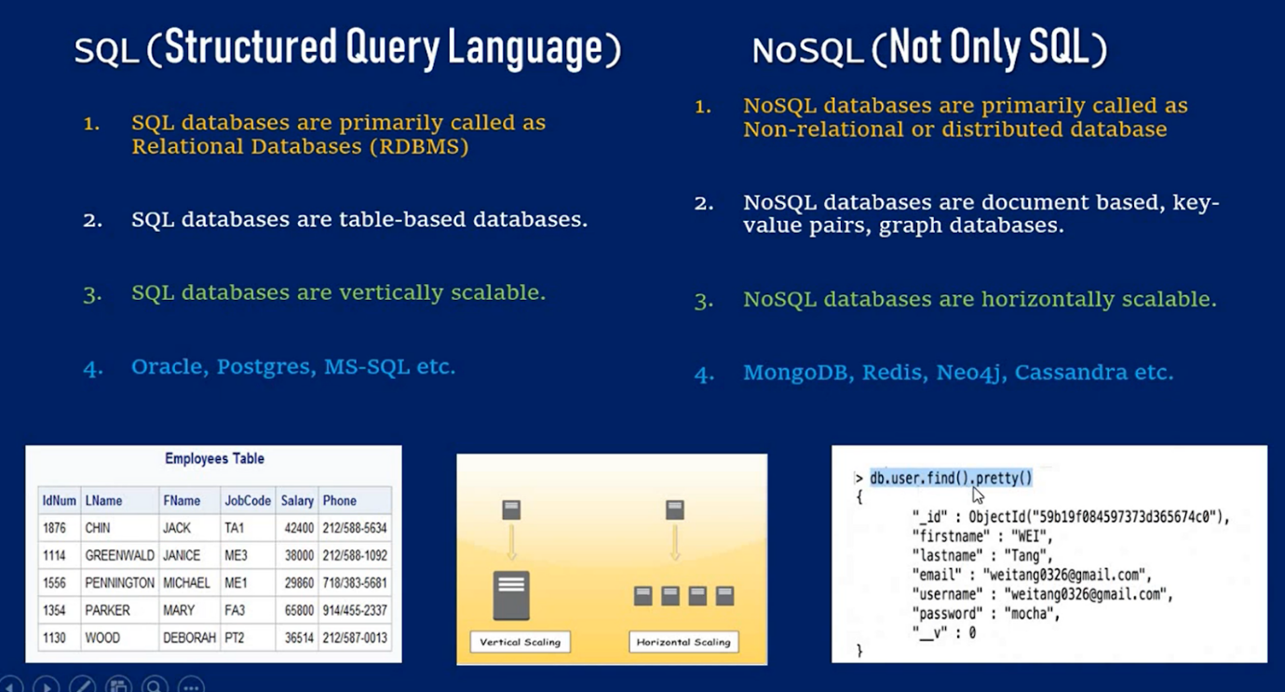

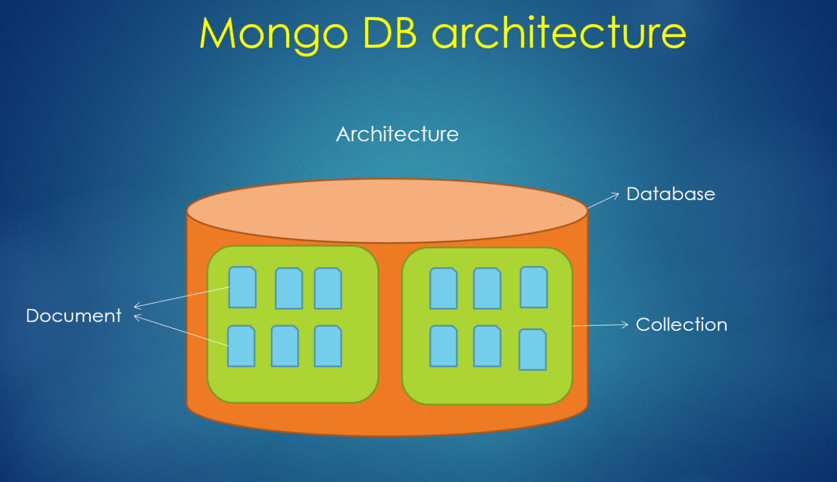

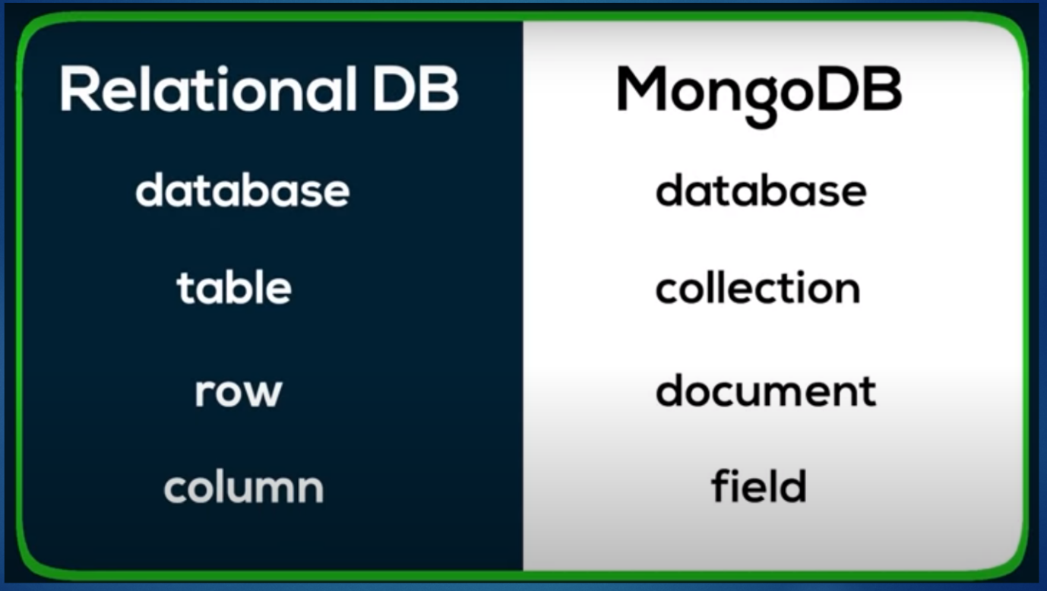

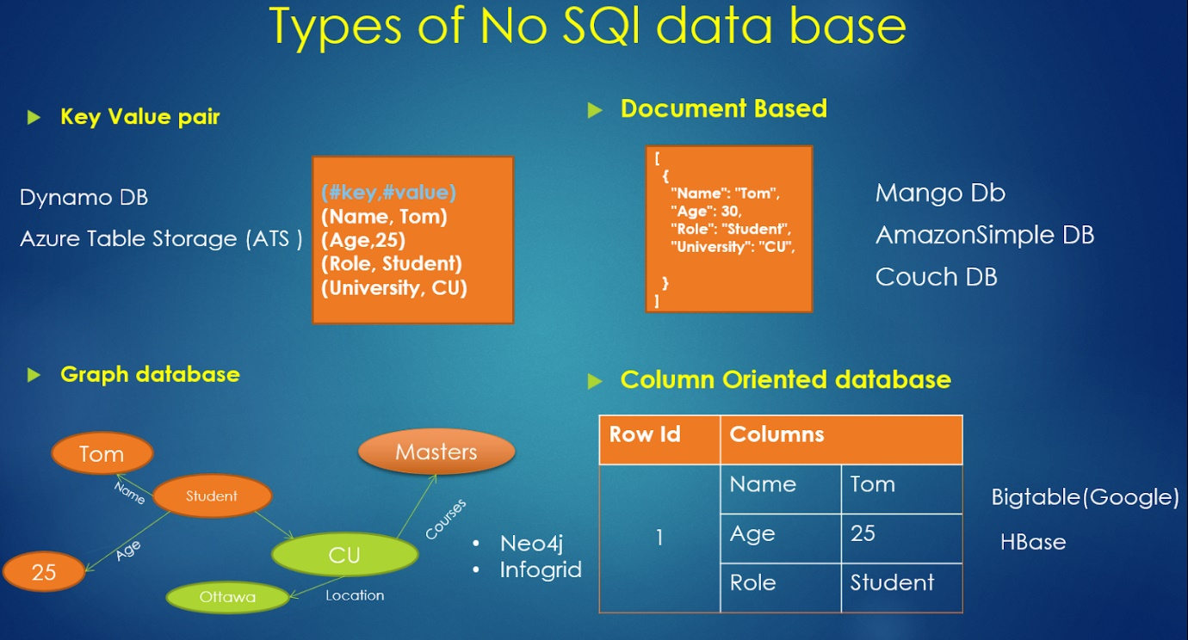

**MongoDB Installation**

[**https://www.mongodb.com/**](https://www.mongodb.com/)

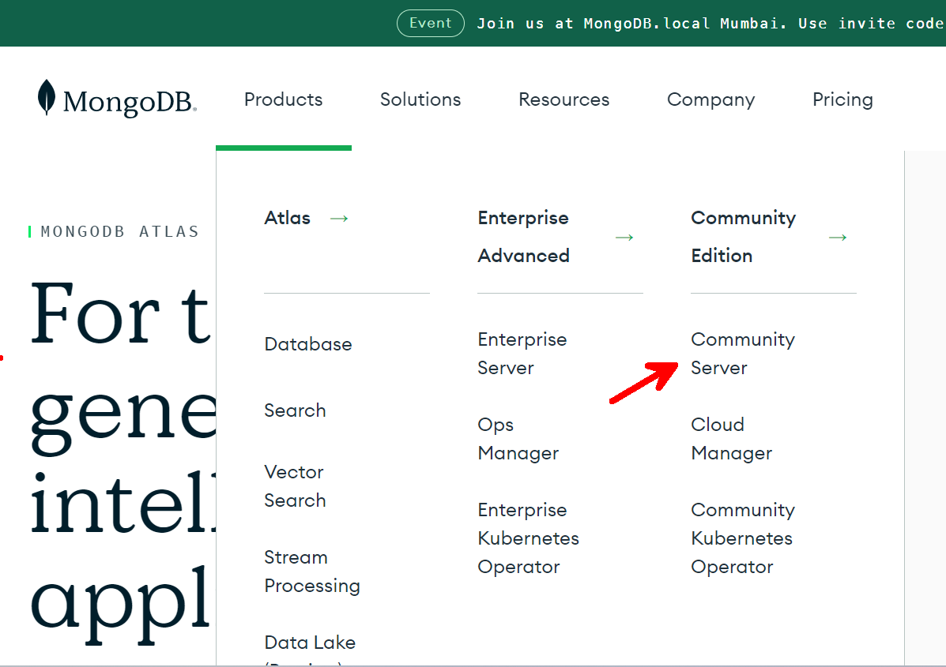

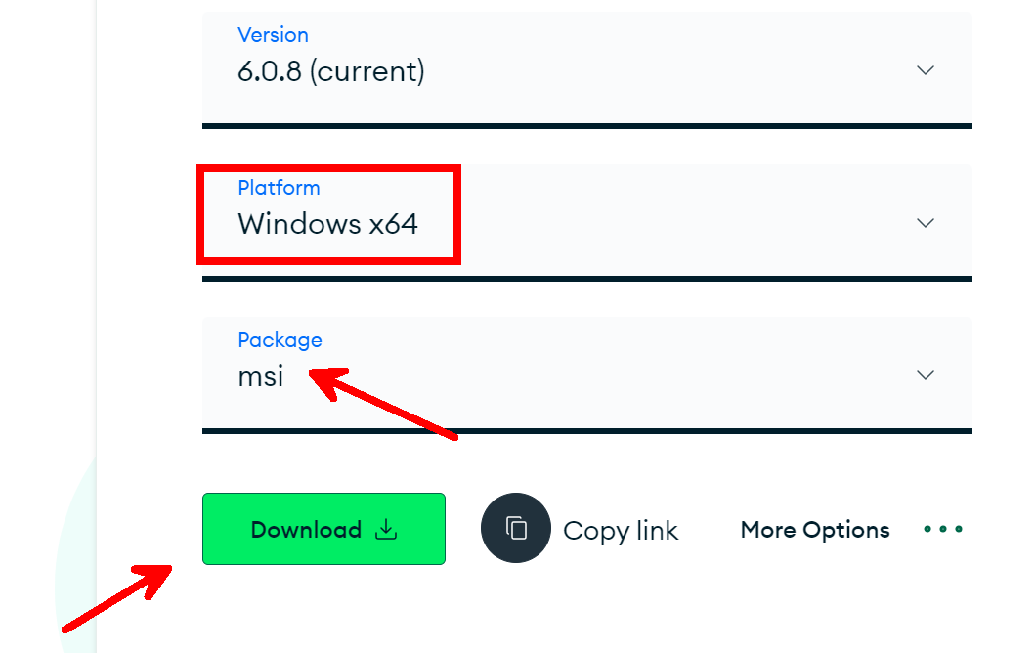

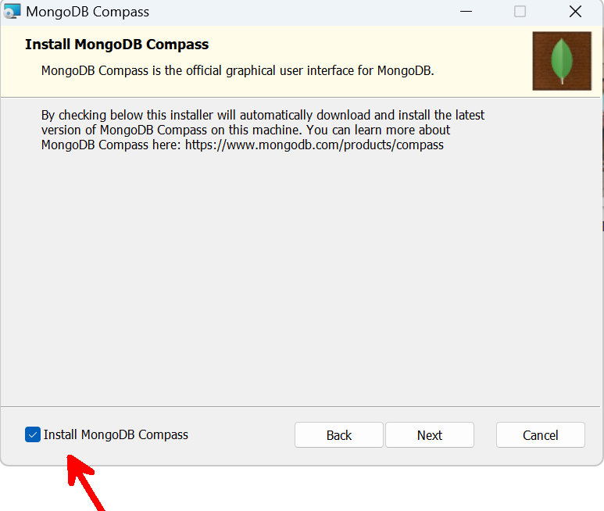

**Click on thick mark to install MongoDB Compass (GUI Version )**

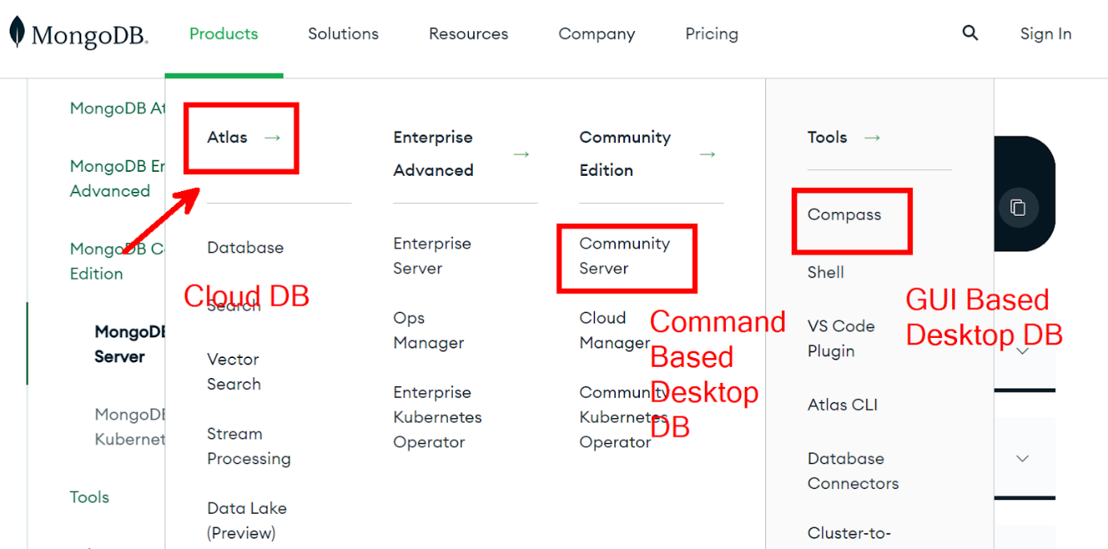

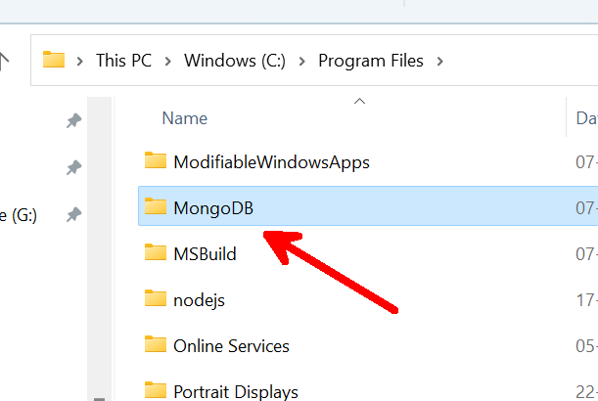

**Set Bin Folder as Environment Variable**

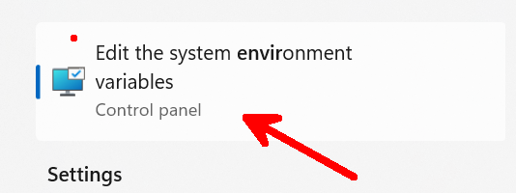

**At C: Drive, Create a folder named data and inside data create another folder with name db.**

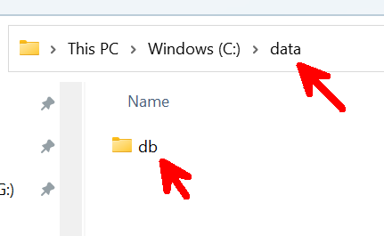

**Open this db folder with cmd Prompt**

**Now run the command > mongod**

(this will run mongo Development Server)

After this the db folder will add some files and folders automatically.

**Now open another command prompt**

**>mongo**

This command is used to start MongoDB Shell

**MongoDB Commands**

**> show dbs**

To display all the databases present in MongoDB

admin   0.000GB

config  0.000GB

local   0.000GB

test    0.000GB

**> show dbs**

admin      0.000GB

config     0.000GB

employees  0.000GB

local      0.000GB

test       0.000GB

**> db**

To show active database

test

**> use employees**

To switch to other database

switched to db employees

**> db**

employees

**> show collections**

To show all collection in current database

managers

students

**> db.students.find()**

To show all documents in current collection

{ "_id" : ObjectId("64d7a4bf64b24bab5d2a4ddb"), "name" : "Fatima", "role" : "student" }

{ "_id" : ObjectId("64d7a4d964b24bab5d2a4ddc"), "name" : "Vinod", "role" : "student" }

{ "_id" : ObjectId("64d7a4e264b24bab5d2a4ddd"), "name" : "Pratiksha", "role" : "student" }

{ "_id" : ObjectId("64d7a4eb64b24bab5d2a4dde"), "name" : "Chandershekhar", "role" : "student" }

**>  db.managers.find()**

To show all documents in managers collection

{ "_id" : ObjectId("64d7a3b864b24bab5d2a4dd5"), "name" : "John", "role" : "Developer" }

{ "_id" : ObjectId("64d7a3e264b24bab5d2a4dd6"), "firtname" : "Pankaj", "age" : 35 }

>

Session-48 MongoDB Crud Operations